**TO SUPPLY LEFTOVER FOOD TO POOR**

**BY**

**DIYA DAS**

[**2111CS030030@mallareddyuniversity.ac.in**](mailto:2111CS030030@mallareddyuniversity.ac.in)

**PROJECT ABSTRACT**

**Title : To supply leftover food to poor**

Supplying leftover food to those in need addresses two critical issues: food insecurity and food waste. Every year, millions of pounds of food are discarded by restaurants, supermarkets, and households while many individuals and families struggle to access nutritious meals. By redistributing leftover food that is safe and fresh, we can provide immediate relief to those facing hunger, reduce waste, and promote a more sustainable society. Coordinating efforts among local businesses, nonprofits, volunteers, and communities allows us to create an efficient system for collecting and delivering surplus food to those who need it most. This initiative not only supports individuals in need but also fosters a culture of compassion and responsibility towards our environment.The concept of supplying leftover food to those in need has emerged as a vital solution to two pressing global challenges hunger and food waste.

Despite living in an age of abundance, countless communities around the world face food insecurity daily. At the same time, vast quantities of edible food end up in landfills, contributing to environmental issues such as greenhouse gas emissions. Redistributing surplus food from restaurants, grocery stores, schools, and households to those who need it creates a win-win situation—reducing waste and providing nourishment. By building partnerships with local businesses and organizations, we can create an organized network where food is safely collected, packaged, and distributed to underserved communities. Technology can play a significant role, with food rescue apps and community fridges allowing for easy access and coordination among donors and recipients. Volunteers are essential in making this process seamless; with their support, food can reach individuals and families quickly and efficiently.

These efforts aren’t only about providing food—they represent a step towards creating more resilient and supportive communities. Educating the public about food waste and encouraging sustainable practices helps to shift mindsets, fostering a culture where excess food is seen as an opportunity to help others rather than something to discard. By uniting resources, raising awareness, and working together, we can make a meaningful impact on food security and work toward a future where everyone has access to the food they need.

**Keywords**: salesforce, Custom object , Tabs , The Lightning App , Fields , Flows , Trigger , profiles , Creation of users , Public Groups , Report types , Reports ,Dashboard , Sharing Rules,Conclusion.

**INDEX PAGE**

**Topics PAGE NO**

1. Introduction to salesforce 3

2. Object 4

3. Tabs 7

4. The Lightning App 8

5. Field 10

6.Flows 20

7.Trigger 23

8.Profiles 24

9.Creation of users 25

10.Public Groups 25

11.Report Types 26

12.Reports 26

13.Dashboards 28

14.Sharing Rules 30

15.Home page 31

16.Conclusion 32

**Task 1 : Introduction to Salesforces**

* 1. Creating Developer Account

Creating a developer org in salesforce.

1. Go to <https://developer.salesforce.com/signup>
2. On the sign up form, enter the following details :
3. 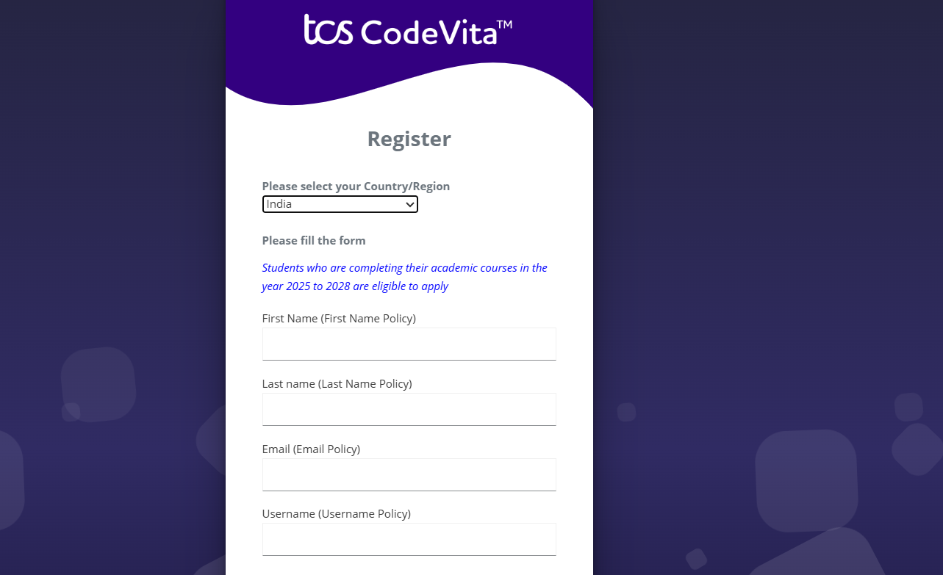

* 1. First name & Last name
  2. Email
  3. Role : Developer
  4. Company : College or Company Name
  5. County : India
  6. Postal Code : pin code
  7. Username : should be a combination of your name and company

This need not be an actual email id, you can give anything in the format :

username@organization.com

Click on sign me up after filling these.

* 1. **Account Activation**

Then you will redirect to your salesforce setup page.

**Task 2 : Object**

Salesforce objects are of two types:

Standard Objects: Standard objects are the kind of objects that are provided by salesforce.com such as users, contracts, reports, dashboards, etc. Custom Objects: Custom objects are those objects that are created by users. They supply information that is unique and essential to their organization. They are the heart of any application and provide a structure for sharing data.

To Navigate to Setup page:

Click on gear icon -click setup.

To create an object:

1. From the setup page - Click on Object Manager - Click on Create - Click on Custom Object.

2. On Custom object defining page:

3. Enter the label name, plural label name, click on Allow reports, Allow search.

4. Click on Save.

**2.1 Create Venue Object :**

To create an object:

1. From the setup page >> Click on Object Manager >> Click on Create >>Click on Custom Object.
2. Enter the label name >> Venue
3. Plural label name >> Venues
4. Enter Record Name Label and Format

* Record Name >> Venue Name
* Data Type >> Text

1. Click on Allow reports and Track Field History,Allow Activities.
2. Allow search >> Save.

**2.2 Create Drop-Off Point Object**

To create an object:

1. From the setup page >> Click on Object Manager >> Click on Create >> Click on Custom Object.
2. Enter the label name >> Drop-Off Point
3. Plural label name>> Drop-Off Points
4. Enter Record Name Label and Format

* Record Name >> Drop-Off point Name
* Data Type >> Text

1. Click on Allow reports and Track Field History,Allow Activities
2. Allow search >> Save.

**2.3 Create Task Object**

To create an object: 3

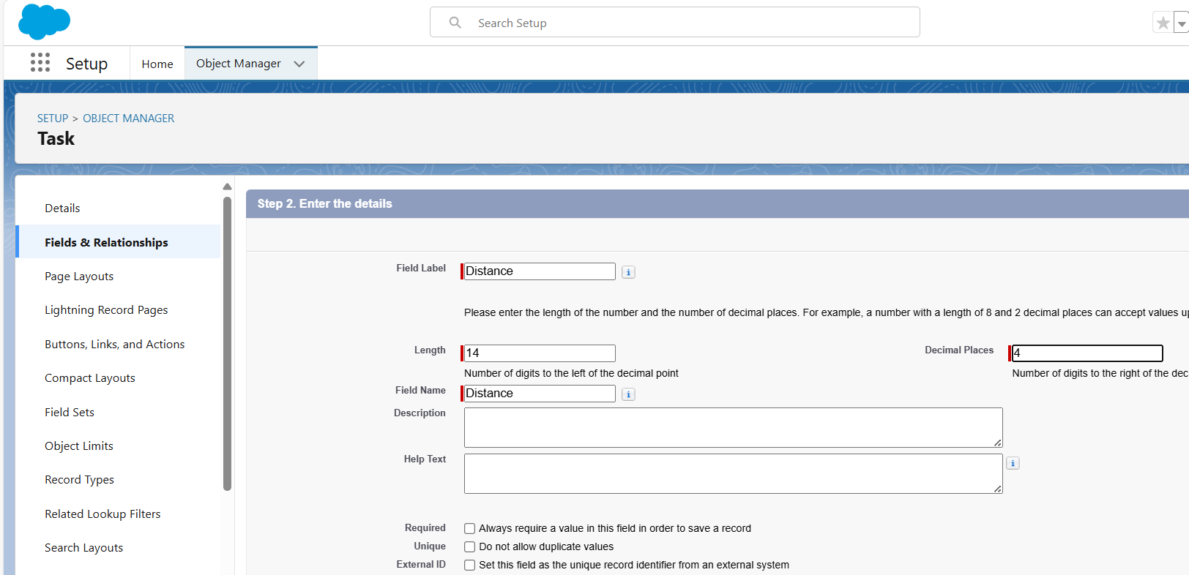

1. From the setup page >> Click on Object Manager >> Click on Create >> Click on Custom Object.
2. Enter the label name>> Task
3. Plural label name>> Tasks
4. Enter Record Name Label and Format

* Record Name >> Task Name
* Data Type >> Text

1. Click on Allow reports and Track Field History,Allow Activities
2. Allow search >> Save.

**2.4 Create Volunteer Object**

To create an object:

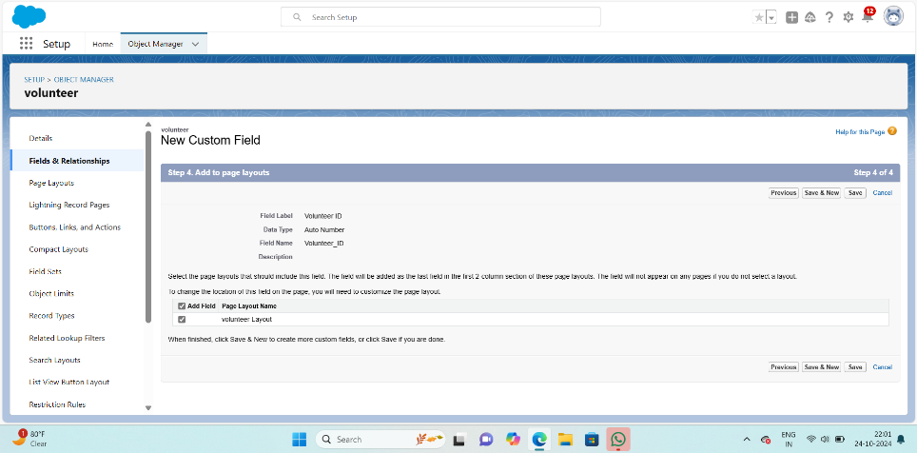

1. From the setup page >> Click on Object Manager>> Click on Create >> Click on Custom Object.
2. Enter the label name>> Volunteer
3. Plural label name>> Volunteers
4. Enter Record Name Label and Format

* Record Name >> Volunteer Name
* Data Type >> Text

1. Click on Allow reports and Track Field History, Allow Activities
2. Allow search >> Save.

2.5 **Create Execution Details Object**

To create an object:

1. From the setup page >> Click on Object Manager >> Click on Create >> Click on Custom Object.
2. Enter the label name >> Execution Detail
3. Plural label name >> Execution Details
4. Enter Record Name Label and Format

* Record Name >> Execution Detail Name
* Data Type >> Text

1. Click on Allow reports and Track Field History, Allow Activities
2. Allow search >> Save.

**Task 3: Tabs**

A tab is like a user interface that is used to build records for objects and to view the records in the objects.

3.1 **Creating a Custom Tab**

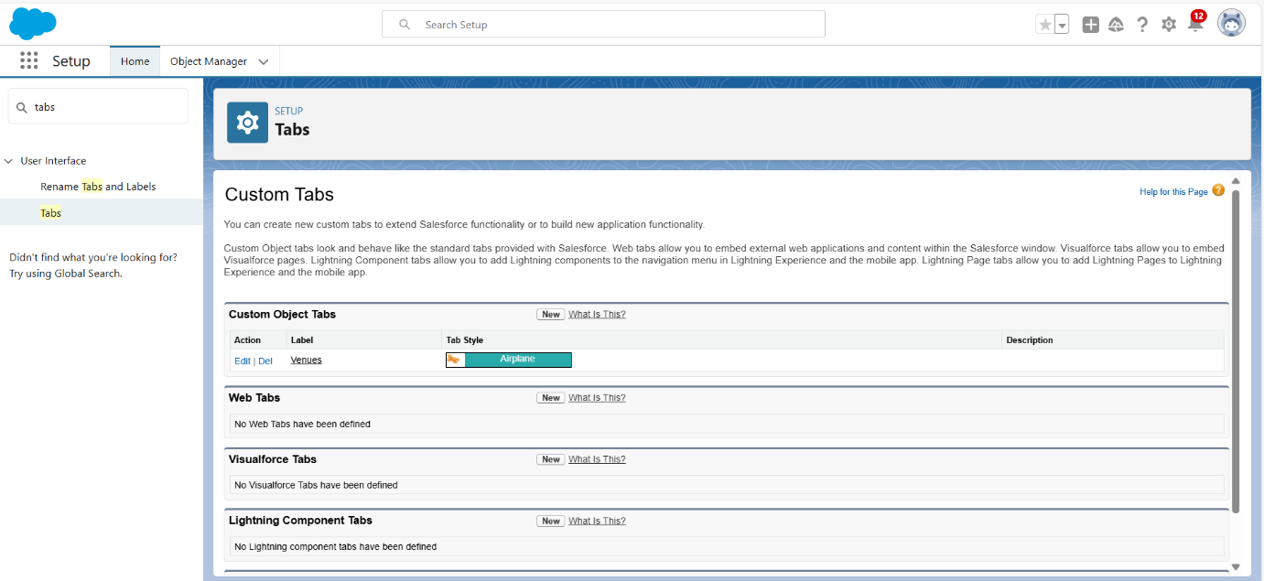

To create a Tab:(Venue)

1. Go to setup page >> type Tabs in Quick Find bar >> click on tabs >> New (under custom object tab)
2. Select Object(Venue) >> Select the tab style >> Next (Add to profiles page) keep it as default >> Next (Add to Custom App) uncheck the include tab .

1. Make sure that the Append tab to users' existing personal customizations is checked.

1. Click save.

3.2 **Creating Remaining Tabs**

1. Now create the Tabs for the remaining Objects, they are “Drop-Off Point, Task, Volunteer, Execution Details”.
2. Follow the same steps as mentioned in Activity -1 .

**Task 4 :The Lightning App**

To create a lightning app page:

1. Go to setup page >> search “app manager” in quick find >> select “app manager” >> click on New lightning App.
2. 2. Fill the app name in app details and branding as follow  
   App Name : FoodConnect  
   Developer Name : This will auto populated  
   Image : optional (if you want to give any image you can otherwise not mandatory) Primary color hex value : keep this default.
3. 3.Then click Next >> (App option page)Set Navigation Style as Standard Navigation >> Next.

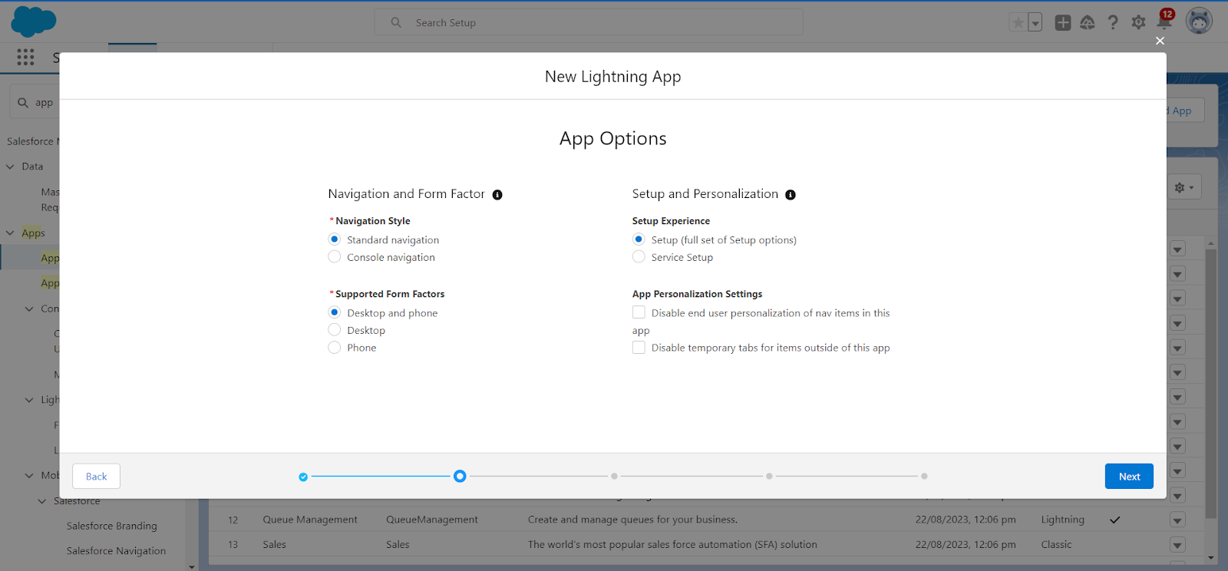

4. (Utility Items) keep it as default >> Next.  
5. To Add Navigation Items:

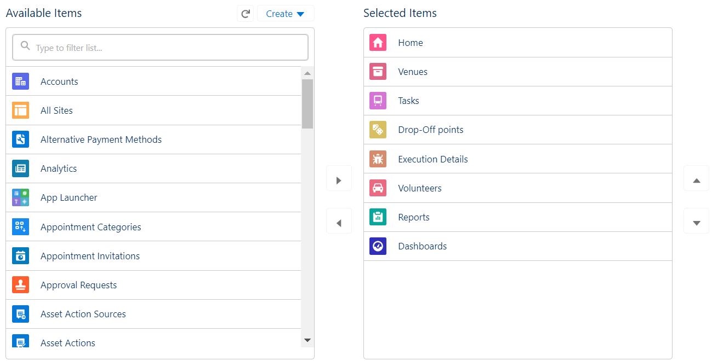

Search for the item in the (Home, Venue, Drop-Off Point, Task, Volunteer, Execution Details, Reports) from the search bar and move it using the arrow button >> Next >> Next.

6. To Add User Profiles:

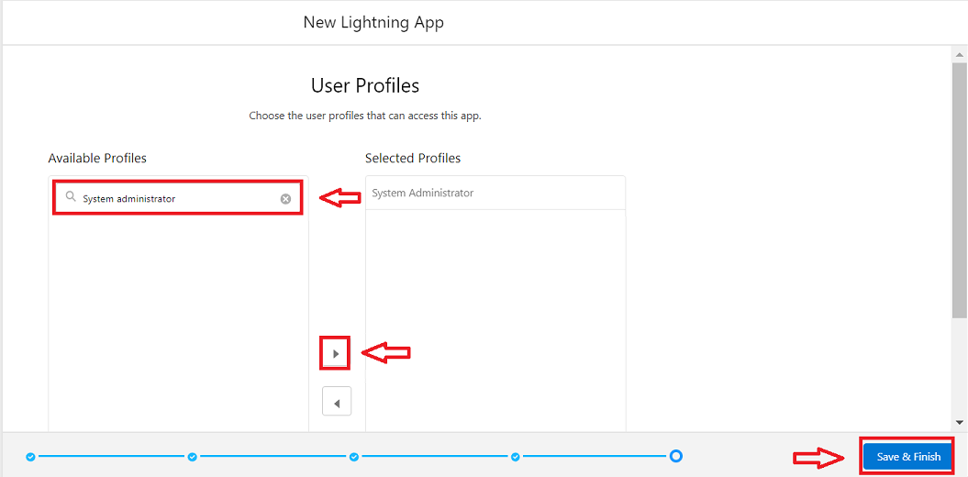

Search profiles (System administrator) in the search bar >> click on the arrow button >> save & finish.

**TASK 5 : Field**

Creation of Relationship fields in objects

**5.1 Creation of Lookup Relationship Field on Volunteer Object**

1. Go to setup >> click on Object Manager >> type object name(Volunteer) in the search bar >> click on the object.

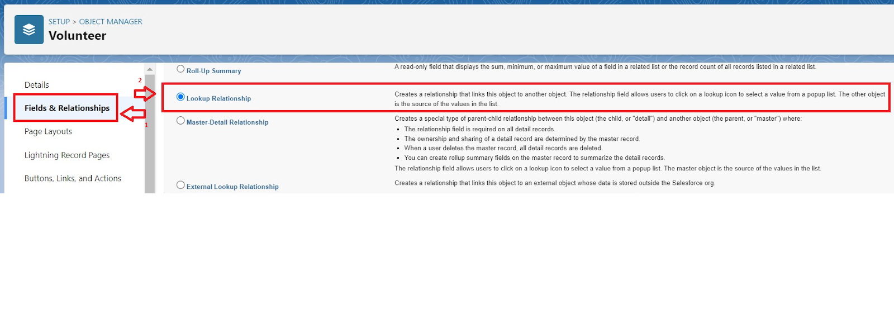

1. Now click on “Fields & Relationships” >> New
2. Select Master Detail relationship
3. Select the related object “Drop-Off point” and click next.

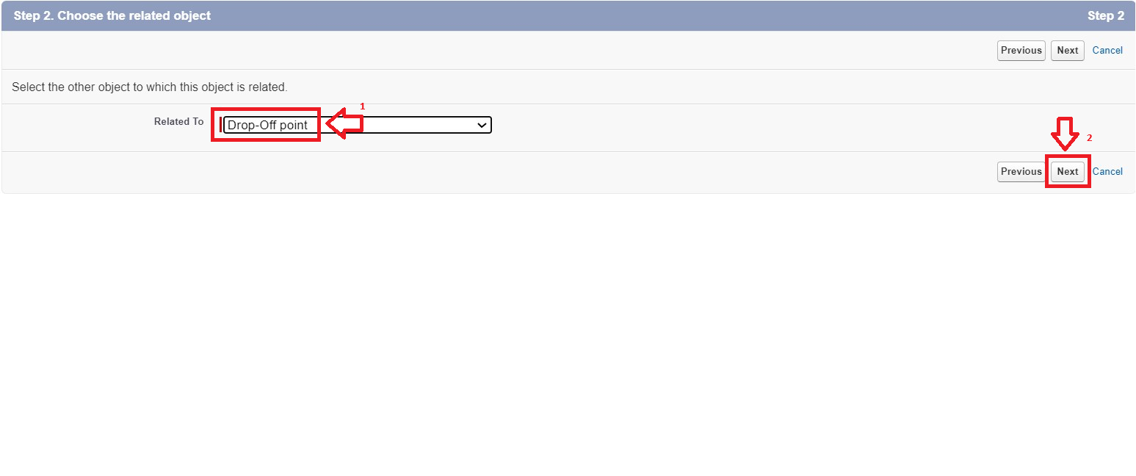

1. Field Name : Drop_Off_point
2. Field label : Auto generated
3. Next >> Next >> Save.

**Creation of Master Detail Relationship Field on Execution Details Object :**

1. Go to setup >> click on Object Manager >> type object name(Execution Details) in the search bar >> click on the object.
2. Now click on “Fields & Relationships” >> New
3. Select Master Detail relationship
4. Select the related object “Volunteer” and click next.
5. Field Name : Volunteer
6. Field label : Auto generated
7. Next >> Next >> Save.

Creation of Master Detail Relationship Field on Execution Details Object :

1. Go to setup >> click on Object Manager >> type object name(Execution Details) in the search bar >> click on the object.
2. Now click on “Fields & Relationships” >> New
3. Select Master Detail relationship
4. Select the related object “Task” and click next.
5. Field Name : Task
6. Field label : Auto generated
7. Next >> Next >> Save.

Creation of Lookup Relationship Field on Drop-Off Point Object :

1. Go to setup >> click on Object Manager >> type object name(Task) in the search bar >> click on the object.
2. Now click on “Fields & Relationships” >> New
3. Select Lookup relationship
4. Select the related object “Drop-Off Point” and click next.
5. Field Name : Venue
6. Field label : Venue__c
7. Next >> Next >> Save.

Creation of Lookup Relationship Field on Task Object :

1. Go to setup>> click on Object Manager >> type object name(Task) in the search bar >> click on the object.
2. Now click on “Fields & Relationships” >> New
3. Select Lookup relationship
4. Select the related object “Venue” and click next.
5. Field Name : Sponsored By
6. Field label : Auto generated
7. Next >> Next >> Save.

Creation of Lookup Relationship Field on Task Object :

1. Go to setup>> click on Object Manager >> type object name(Task) in the search bar >> click on the object.
2. Now click on “Fields & Relationships” >> New
3. Select Lookup relationship
4. Select the related object “Drop-Off point” and click next.
5. Field Name : Drop-Off point
6. Field label : Auto generated
7. Next >> Next >> Save.

### 5.2 Creation of fields for the Venue object

1. Go to setup>> click on Object Manager >> type object name(Venue) in search bar >> click on the object.
2. Now click on “Fields & Relationships” >> New
3. Select Data type as a “Email” and Click on Next
4. Fill the Above as following:

* Field Label : Contact Email
* Field Name : Contact Email
* Click on required check box
* Click on Next >> Next >> Save and new.

**To create another fields in an object:**

1. Go to setup >> click on Object Manager >> type object name(Venue) in search bar >> click on the object.
2. Now click on “Fields & Relationships” >> New
3. Select Data type as a “Phone” and Click on Next
4. Fill the Above as following:

* Field Label : Contact Phone
* Field Name : Contact Phone
* Click on required check box
* Click on Next >> Next >> Save and new.

**To create another fields in an object:**

1. Go to setup >> click on Object Manager >> type object name(Venue) in search bar >>click on the object.
2. Now click on “Fields & Relationships” >> New
3. Select Data type as a “Geolocation” and Click on Next
4. Fill the Above as following:

* Field Label : Location
* Decimal Places : 4
* Field Name : Location
* Description : Enter the Geolocation of your Venue
* Click on Next >> Next >> Save and new.

To create another fields in an object:

1. Go to setup >> click on Object Manager >> type object name(Venue) in search bar >> click on the object.
2. Now click on “Fields & Relationships” >> New
3. Select Data type as a “Long Text Area” and Click on Next
4. Fill the Above as following:

* Field Label : Venue Location
* Field Name : Venue_Location
* Click on Next >> Next >> Save and new

### 5.3 Creation of fields for the Drop-Off point object

Go to setup >> click on Object Manager >> type object name(Drop-Off point) in search bar >> click on the object.

2. Now click on “Fields & Relationships” >> New

3. Select Data type as a “Geolocation” and Click on Next

4. Fill the Above as following:

* Field Label : Location 2
* Field Name : gets auto generated
* Description : Enter the Geolocation of the Drop off Point
* Geolocation Options : select Decimal
* Decimal Places : 4
* Click on Next >> Next >> Save and new.

To create another fields in an object:

1. Go to setup >> click on Object Manager >> type object name(Drop-Off point) in search bar >> click on the object.
2. Now click on “Fields & Relationships” >> New
3. Select Data type as a “Formula” and Click on Next
4. Fill the Above as following:

* Field Label : distance calculation
* Field Name : distance_calculation
* Formula Return Type : Number
* Formula Options : DISTANCE( Location_2__c , Venue__r.Location__c , 'km')
* Click on Next >> Next >> Save and new.

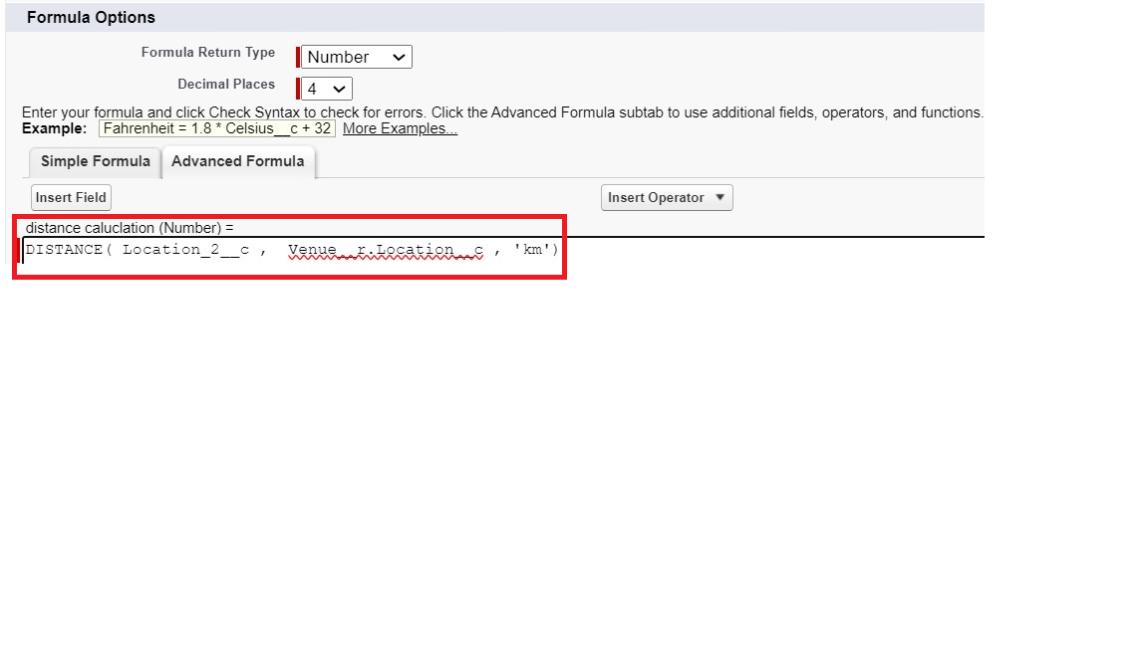

To create another fields in an object:

1. Go to setup >> click on Object Manager >> type object name(Drop-Off point) in search bar >> click on the object.
2. Now click on “Fields & Relationships” >> New
3. Select Data type as a “Picklist” and Click on Next
4. Fill the Above as following:

* Field Label : State
* Field Name : State
* Enter values, with each value separated by a new line :

Andhra Pradesh

Arunachal Pradesh

Assam

Bihar

Chhattisgarh

Goa

Gujarat

Haryana

Himachal Pradesh

Jharkhand

Karnataka

Kerala

Maharashtra

Madhya Pradesh

Manipur

Meghalaya

Mizoram

Nagaland

Odisha

Punjab

Rajasthan

Sikkim

Tamil Nadu

Tripura

Telangana

Uttar Pradesh

Uttarakhand

West Bengal

Andaman & Nicobar (UT)

Chandigarh (UT)

Dadra & Nagar Haveli and Daman & Diu (UT)

Delhi [National Capital Territory (NCT)]

Jammu & Kashmir (UT)

Ladakh (UT)

Lakshadweep (UT)

Puducherry (UT)

* Click on required check box
* Click on Next >> Next >> Save and new.

To create another fields in an object:

1. Go to setup >> click on Object Manager >> type object name(Task) in search bar >> click on the object.
2. Now click on “Fields & Relationships” >> New
3. Select Data type as a “Number” and Click on Next
4. Fill the Above as following:

* Field Label : Distance
* Field Name : Distance
* Length : 14
* Decimal Places : 4
* Click on required check box
* Click on Next >> Next >> Save and new.

### 

### 5.4 Creation of fields for the Task object

Go to setup>> click on Object Manager >> type object name(Task) in search bar >> click on the object.

2. Now click on “Fields & Relationships” >> New

3. Select Data type as a “Auto Number” and Click on Next

4. Fill the Above as following:

* Field Label : Task ID
* Display Format : TASK-{0}
* Starting Number : 1
* Field Name : gets auto generated
* Click on required check box
* Click on Next >> Next >> Save and new.

To create another fields in an object:

1. Go to setup >> click on Object Manager >> type object name(Task) in search bar >> click on the object.
2. Now click on “Fields & Relationships” >> New
3. Select Data type as a “Date” and Click on Next
4. Fill the Above as following:

* Field Label : Date
* Field Name : Date
* Click on required check box
* Click on Next >> Next >> Save and new.

To create another fields in an object:

1. Go to setup >> click on Object Manager >> type object name(Task) in search bar >> click on the object.
2. Now click on “Fields & Relationships” >> New
3. Select Data type as a “Picklist (Multi-Select)” and Click on Next
4. Fill the Above as following:

* Field Label : Food Category
* Field Name : Food Category
* Enter values, with each value separated by a new line :

Veg

Non-Veg

Salad

Snack

* Click on required check box
* Click on Next >> Next >> Save and new.

To create another fields in an object:

1. Go to setup >> click on Object Manager >> type object name(Task) in search bar >> click on the object.
2. Now click on “Fields & Relationships” >> New
3. Select Data type as a “Number” and Click on Next
4. Fill the Above as following:

* Field Label : Number of People Served
* Field Name : Number_of_People_Served
* Click on required check box
* Click on Next >> Next >> Save and new.

To create another fields in an object:

1. Go to setup >> click on Object Manager >> type object name(Task) in search bar >> click on the object.
2. Now click on “Fields & Relationships” >> New
3. Select Data type as a “Text” and Click on Next
4. Fill the Above as following:

* Field Label : Name of the Person
* Field Name : Name_of_the_Person
* Click on Next >> Next >> Save and new.

To create another fields in an object:

1. Go to setup>> click on Object Manager >> type object name(Task) in search bar >> click on the object.
2. Now click on “Fields & Relationships” >> New
3. Select Data type as a “Phone” and Click on Next
4. Fill the Above as following:

* Field Label : Phone
* Field Name : Phone
* Click on Next >> Next>> Save and new.

To create another fields in an object:

1. Go to setup >> click on Object Manager >> type object name(Task) in search bar >> click on the object.
2. Now click on “Fields & Relationships” >> New
3. Select Data type as a “Pick List” and Click on Next
4. Fill the Above as following:

* Field Label : Rating
* Field Name : Rating
* Enter values, with each value separated by a new line :

1

2

3

4

5

* Click on Next >> Next >> Save and new.

To create another fields in an object:

1. Go to setup >> click on Object Manager >> type object name(Task) in search bar >> click on the object.
2. Now click on “Fields & Relationships” >> New
3. Select Data type as a “Long Text Area” and Click on Next
4. Fill the Above as following:

* Field Label : Feedback
* Field Name : Feedback
* Click on Next >> Next >> Save and new.

### 5.5 Creation of fields for the Volunteer object

Go to setup >> click on Object Manager >> type object name(Volunteer) in search bar >> click on the object.

2. Now click on “Fields & Relationships” >> New

3. Select Data type as a “Auto Number” and Click on Next

4. Fill the Above as following:

* Field Label : Volunteer ID
* Field Name : gets auto generated
* Click on required check box
* Click on Next >> Next >> Save and new.
* Click on Next >> Next >> Save and new.

To create another fields in an object:

1. Go to setup >> click on Object Manager >> type object name(Volunteer) in search bar >> click on the object.
2. Now click on “Fields & Relationships” >> New
3. Select Data type as a “Picklist” and Click on Next
4. Fill the Above as following:

* Field Label : Gender
* Field Name : Gender
* Enter values, with each value separated by a new line :

Female

Male

* Click on Next >> Next >> Save and new.

To create another fields in an object:

1. Go to setup >> click on Object Manager >> type object name(Volunteer) in search bar >> click on the object.
2. Now click on “Fields & Relationships” >> New
3. Select Data type as a “Date” and Click on Next
4. Fill the Above as following:

* Field Label : Available On
* Field Name : Available On
* Click on required check box
* Click on Next >> Next >> Save and new.

To create another fields in an object:

1. Go to setup >> click on Object Manager >> type object name(Volunteer) in search bar >> click on the object.
2. Now click on “Fields & Relationships” >> New
3. Select Data type as a “Number” and Click on Next
4. Fill the Above as following:

* Field Label : Age
* Field Name : Age
* Click on required check box
* Click on Next >> Next>> Save and new.

To create another fields in an object:

1. Go to setup >> click on Object Manager >> type object name(Volunteer) in search bar >> click on the object.
2. Now click on “Fields & Relationships” >> New
3. Select Data type as a “Email” and Click on Next
4. Fill the Above as following:

* Field Label : Email
* Field Name : Email
* Click on required check box
* Click on Next>> Next >> Save and new.

To create another fields in an object:

1. Go to setup >> click on Object Manager >> type object name(Volunteer) in search bar >> click on the object.
2. Now click on “Fields & Relationships” >> New
3. Select Data type as a “Number” and Click on Next
4. Fill the Above as following:

* Field Label : Contact Number
* Field Name : Contact_Number
* Click on required check box
* Click on Next >> Next >> Save and new.

To create another fields in an object:

1. Go to setup >> click on Object Manager >> type object name(Volunteer) in search bar >> click on the object.
2. Now click on “Fields & Relationships” >> New
3. Select Data type as a “Text Area (Long)” and Click on Next
4. Fill the Above as following:

* Field Label : Address
* Field Name : Address
* Click on Next >> Next >> Save and new.

To create another fields in an object:

1. Go to setup >> click on Object Manager >> type object name(Volunteer) in search bar >> click on the object.
2. Now click on “Fields & Relationships” >> New
3. Select Data type as a “Date” and Click on Next
4. Fill the Above as following:

* Field Label : Date of Birth
* Field Name : Date_of_Birth
* Click on Next >> Next >> Save and new.

### 5.6 Creation of fields for the Execution Details object

1.Go to setup >> click on Object Manager >> type object name(Volunteer) in search bar >> click on the object.

2. Now click on “Fields & Relationships” >> New

3. Select Data type as a “Auto Number” and Click on Next

4. Fill the Above as following:

* Field Label : Execution ID
* Field Name : gets auto generated
* Click on required check box
* Click on Next >> Next >> Save and new.

**TASK 6 : Flows**

### Create Flow to create a record in Venue object

1. Go to setup >> type Flow in quick find box >> Click on the Flow and Select the New Flow.
2. Select the Screen flow. Click o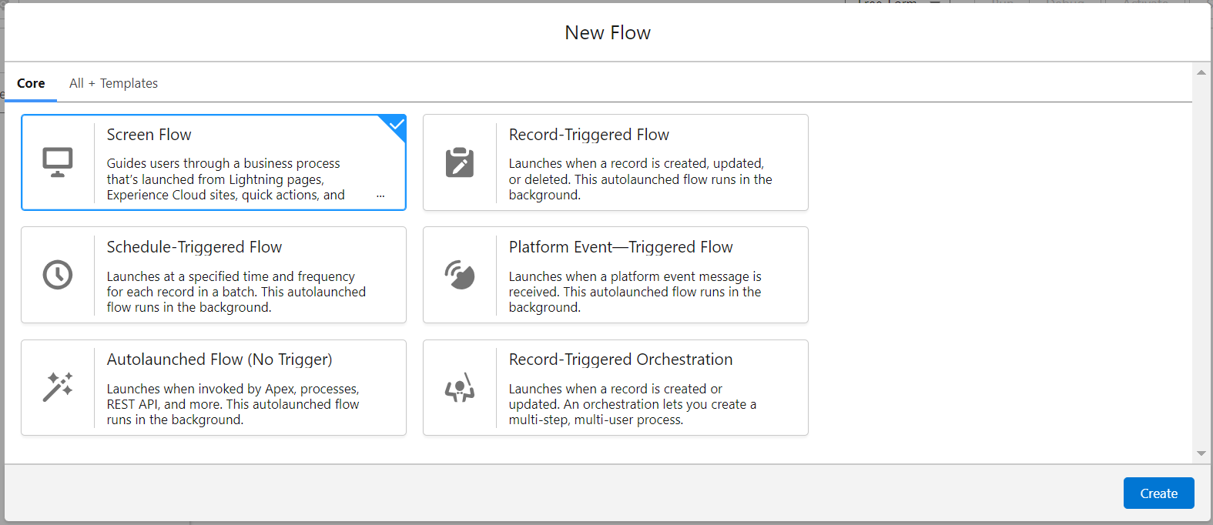create.
3. Click on the ‘+’ icon in between start and end, and click on screen element.
4. Under the Screen Properties:

Label : Venue Details

API Name : Venue_Details

1. Now lets add components in this flow. Click on Text Component and name it as:

Label : Venue Name

API Name : Venue_Name

1. Click on Email Component and name it as:

Label : Email

API Name : Contact_Email

1. Click on Phone Component and name it as:

Label : Phone

API Name : Contact_Phone

1. Click on Text Component and name it as:

Label : Venue Location

API Name : Venue_Location

1. Click on Number Component and name it as:

Label : Latitude

API Name : Latitude

1. Click on Number Component and name it as:

Label : longitude

API Name : longitude

1. Next click on Done. This would like below

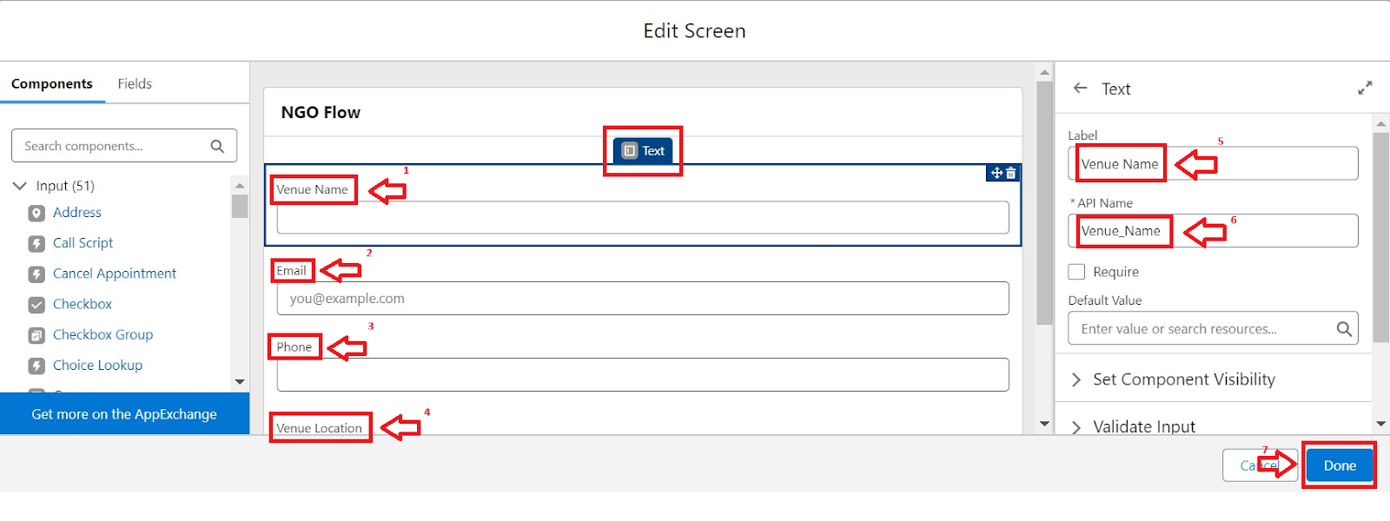

1. Click on the ‘+’ icon in between Venue details and end, and click on create record element.
2. Now label it as

Label : Create Venue Record

API Name : Create_Venue_Record

How Many Records to Create : One

How to Set the Record Fields : Use separate resources, and literal values

Object : Venue

Set Field Values for the Venue : Click on ‘Add Field’ 5 times

Field : Value = Contact_Email__c : {!Contact_Email.value}

Field : Value = Contact_Phone__c : {!Contact_Phone.value}

Field : Value = Name : {!Venue_Name}

Field : Value = Venue_Location__c : {!location}

Field : Value = Location__Latitude__s : {!latitude}

Field : Value = Location__Longitude__s : {!longitude}

1. This would look like:

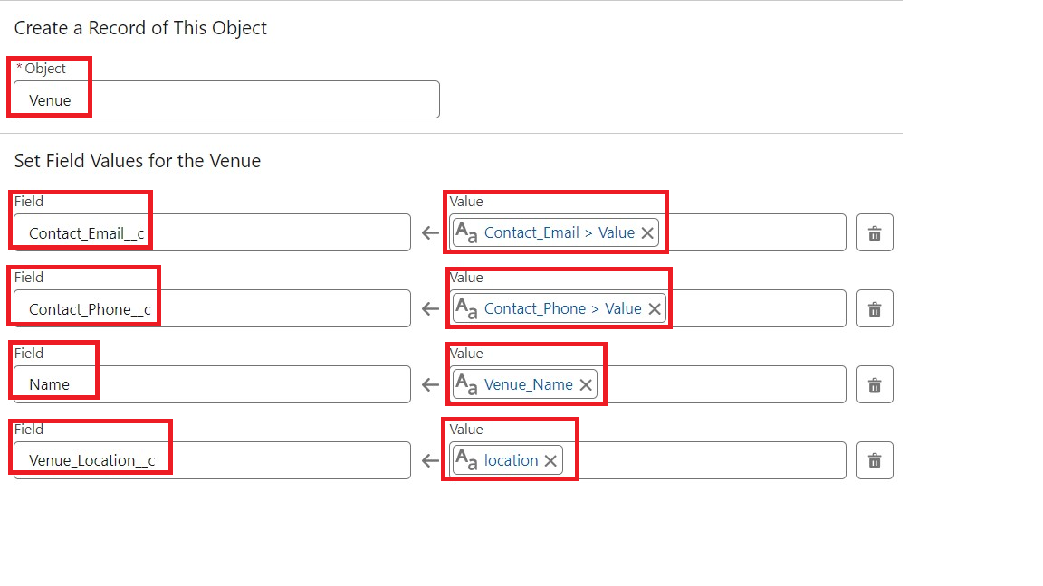

1. Click on Save as:

Flow Label : Venue Form

Flow API Name : Venue_Form

TASK 6 : Trigger

6.1 Create a trigger:

1. Log into the trailhead account, navigate to the gear icon in the top right corner.
2. Click on developer console and you will be navigated to a new console window.
3. Click on the File menu in the toolbar, and click on new >> Trigger.
4. Enter the trigger name and the object to be triggered.

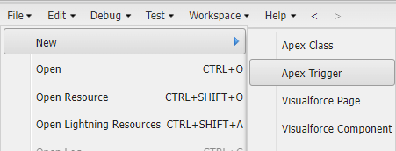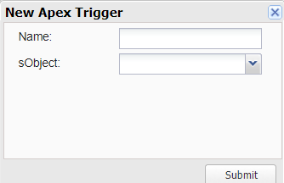

1. Enter Name : DropOffTrigger

sObject: Drop-Off Point

1. Click on Submit.

**6.2 Trigger Code****:**

This Trigger is to assign Distance field to the Distance Calculation field. So that we can assign the distance in the sharing rule.

**Code:**

trigger DropOffTrigger on Drop_Off_point__c (before insert) {

for(Drop_Off_point__c Drop : Trigger.new){

Drop.Distance__c = Drop.distance_calculation__c;

}

}

**TASK 7: Profiles**

1. Go to setup page >> type Profiles in Quick Find bar >> click on Profiles >> click on ‘S’
2. Click on Clone beside Standard Platform User.
3. Under Clone Profile:

Profile Name : NGOs Profile

4. Then click on Save

**TASK 8 : Creation of User**

**8.1 Creation of User1:**

1. Go to setup page >> type users in Quick Find bar >> click on users>> New user.
2. In General Information give details as: (Note : create users as per your wish NGO’s)

First Name : Iksha Foundation

Last Name : Iksha_Foundation

Alias : iiksh

Email : Give Your Email

Username : [ikshafoundation@sb.com](mailto:ikshafoundation@sb.com) (give the username different)

Nickname : Auto Populated

User License : Salesforce Platform

Profile : NGOs Profile

Active : Check

1. Click on Save

**8.2 Creation of User2,User 3 :**

1. Create another Two Users by following steps in Activity - 1 with similar User License and Profile.
2. Give Different First Name, Last Name based on Different NGO’s.



**TASK 9: Public Groups**

**9.1: Creation of Public Group 1:**

1. Go to setup page >> type Public Groups in Quick Find bar >> click on Public Groups >> click on New.
2. Under Group Information:

Label : Iksha

Group Name : Iksha

Grant Access Using Hierarchies : Check

1. In Search, Select Users.
2. In Selected Members Add Iksha Foundation and System Administrator

**9.2: Creation of Public Group 2:**

1. By Following Steps in Activity 1, Create other two Public Groups for other two users.
2. After Saving this would look like this.

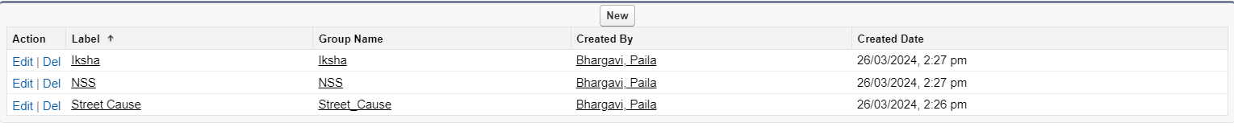

**TASK 10 : Reports Types**

1. Go to setup page >> type Report Types in Quick Find bar >> click on Report Types >> click on Continue >> Click on New Custom Report Type.
2. In Define the Custom Report Type:

Primary Object : Select Venues

Report Type Label : Venue with DropOff with Volunteer

Report Type Name : Venue_with_DropOff_with_Volunteer

Description : Venue with DropOff with Volunteer

Store in Category : Select Other Reports

Deployment Status : Deployed

1. Click on Next
2. Near Click to relate another Object Select Drop-Off Points.
3. And also select "A" records may or may not have related "B" records.
4. Now again Near Click to relate another Object Select Volunteers.
5. Now click on Save.

**TASK 11 : Reports**

**11.1 Creation of Report on Venue with DropOff with Volunteer** **:**

1. Go to the app(FoodConnect) >> click on the reports tab
2. Click on New Folder.

Folder Label : Custom Reports

Folder Unique Name : CustomReports

1. Open Custom Reports and click on New Report
2. Select Report Type : Venue with DropOff with Volunteer
3. Then click on Start Report.
4. In GROUP ROWS : Add Volunteer Name
5. In Columns : Add Venue Name, Drop-Off point Name, Distance.

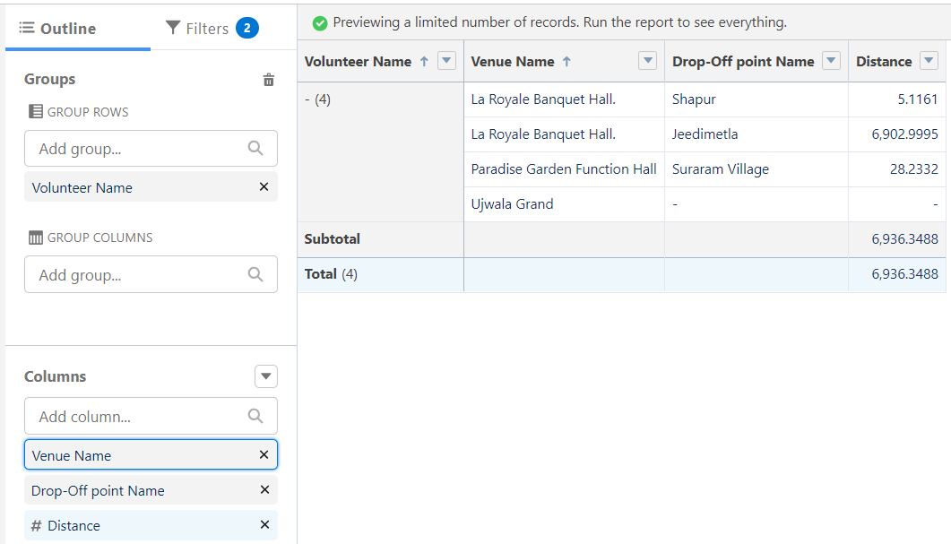

1. Now click on Save & Run.
2. Give Label as :
3. Report Name : venue and Drop Off point
4. Report Unique Name : Auto Populated
5. Click on Select Folder and select Custom Report, then click on Save.

11.2 Creation of Report on Volunteers with Execution Details and Tasks

1. Go to the app(FoodConnect) >> click on the reports tab
2. Click on Custom Reports Folder and click on New Report
3. Select Report Type : Volunteers with Execution Details and Tasks.
4. Then click on Start Report.
5. In GROUP ROWS : Volunteer ID
6. In Columns : Add Volunteer : Volunteer Name, Task : Task Name, Execution Detail : Execution Detail Name, Volunteer: Owner Name, Task: Date, Task : Rating.

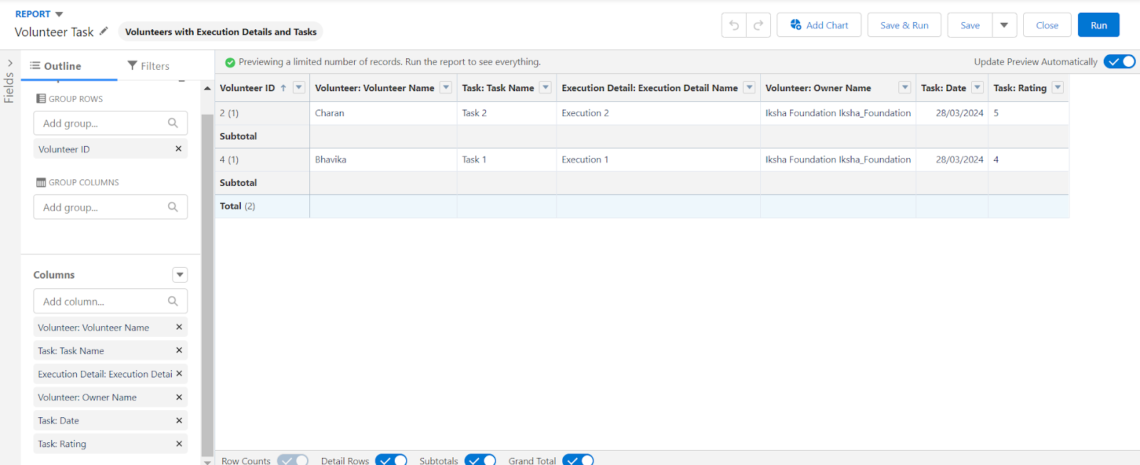

7. Now click on Save & Run.

8. Give Label as :

Report Name : Volunteer Task

Report Unique Name : Auto Populated

1. Click on Select Folder and select Custom Report, then click on Save.

**TASK 12: Dashboards**

**12.1 Adding venue and Drop Off point Report to the Dashboard****:**

1. Go to the app(FoodConnect) >> click on the Dashboards tab.
2. Click on New Folder.

Folder Label : Custom Dashboards

Folder Unique Name : Auto Populated

1. Open Custom Dashboards and click on New Dashboards
2. Name : Organization Details
3. Click on Widget and select Chart or Table
4. In Select Report : Select venue and Drop Off point Report.
5. Then click on select
6. In Add Component:

Display As : Select Lightning Table

Component Theme : Select Dark (Optional)

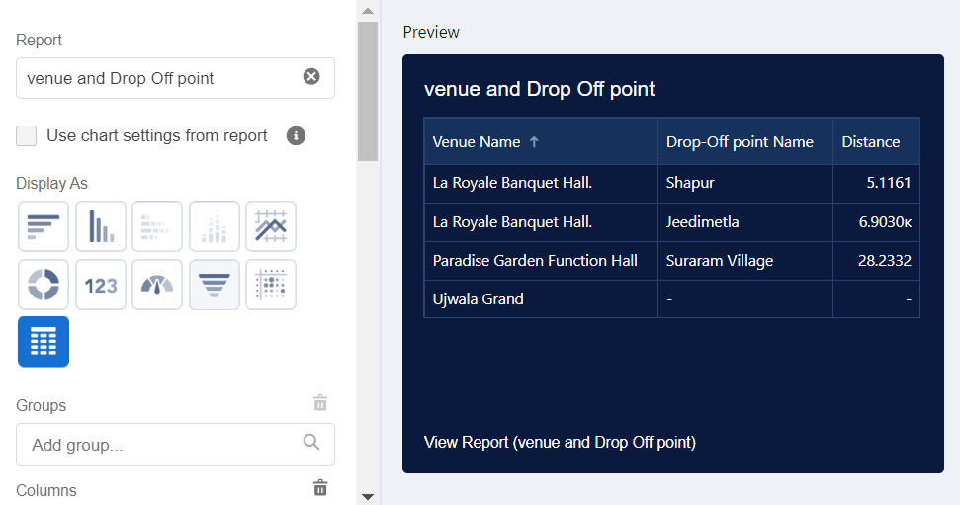

### 12.2 Adding Volunteer Task Report to the Dashboard:

1. Click on Widget and select Chart or Table
2. In Select Report : Select Volunteer Task Report.
3. Then click on select
4. In Add Component:

Display As : Select Line Chart

Component Theme : Select Dark (Optional)

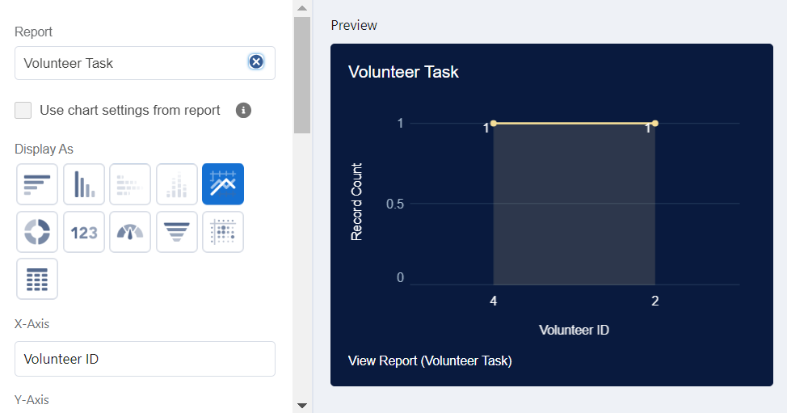

5. Now click on save.

1**2.3 Adding a Picture to the Dashboard (Optional)****:**

1. Click on Widget and select Image. Then click on Browse Files.
2. Then Select the Picture you want to upload in this Dashboard.
3. Then click on Save As :

Name : Task Execution Details

Click on Select Folder and select Custom Dashboards

1. Click on Select Folder and then Save.

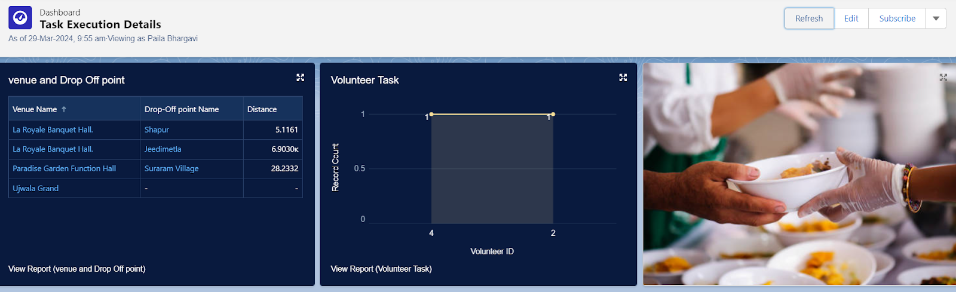

**TASK 13 : Sharing rules**

1. Go to setup >> type Sharing Settings in quick find box >> Click on the Sharing Settings.
2. Scroll down and find Drop-Off point Sharing Rules.
3. Click on new near Drop-Off point Sharing Rules and Name it as:

Label : Rule 1

Rule Name : Rule_1

1. Select your rule type : Select Based on criteria.
2. Select which records to be shared:

Field : Operator : Value = Distance : less than : 15

1. Select the users to share with : Near Share With

Public Groups : Iksha

1. Click on Save.
2. Click on new near Drop-Off point Sharing Rules and Name it as:

Label : Rule 2

Rule Name : Rule_2

1. Select your rule type : Select Based on criteria.
2. Select which records to be shared:

Field : Operator : Value = Distance : greater than : 15

Field : Operator : Value = Distance : less or equal : 30

1. Select the users to share with : Near Share With

Public Groups : NSS

1. Click on Save.
2. Click on new near Drop-Off point Sharing Rules and Name it as:

Label : Rule 3

Rule Name : Rule_3

1. Select your rule type : Select Based on criteria.
2. Select which records to be shared:

Field : Operator : Value = Distance : greater than : 30

Field : Operator : Value = Distance : less or equal : 50

1. Select the users to share with : Near Share With

Public Groups : Street Cause

1. Click on Save.

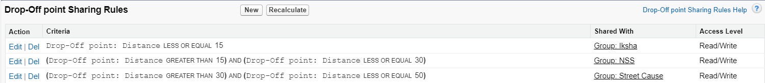

**TASK 13 : Home Page**

1. Go to setup >> type Lightning App Builder in quick find box >> Click on the Lightning App Builder and Select the New.
2. Select Home Page and give Label as HOME Page.
3. Select Standard Home Page.
4. Near Components search for Flow and Drag and Drop in Right Side Section..
5. On the right hand side:

Flow : Venue Flow

1. Near Components search for Dashboard, then Drag and Drop it in first Section.

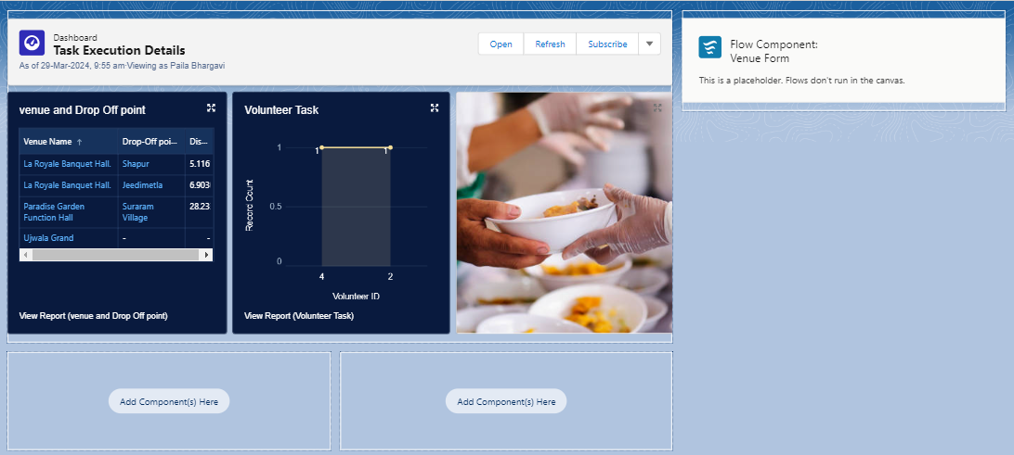

1. Click on Save and Activation, then click on App Default, then Add Assignments.
2. Add FoodConnect App and then Save.
3. FoodConnect Home Page would Look Like this.

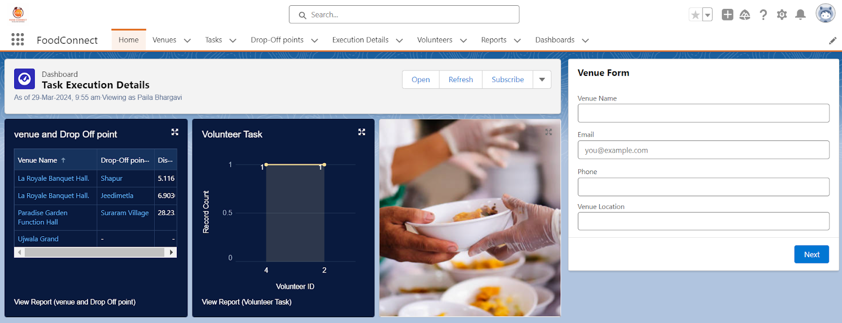

**TASK 14: Conclusion**

By leveraging the Salesforce platform, supplying leftover food to those in need is a compassionate and effective way to address food waste and hunger. By redistributing surplus food, we not only provide nourishment to vulnerable communities but also promote sustainability and community engagement. Initiatives aimed at facilitating this process can foster collaboration among businesses, nonprofits, and volunteers, creating a more equitable food system. Ultimately, this practice reflects our shared responsibility to care for one another and the environment, paving the way for a healthier, more inclusive society.

THANKYOU